Task: Linux Permissions

Objective
Changing the permission of a file in Linux and reading its content from /home/student/practice/restricted_file.txt

Task Performed
Objective: Understand how permissions work in Linux and read the content of /home/student/practice/restricted_file.txt

Flag Captured
Flag: flag{you_understood_permissions}

Commands Used
Command | Description & Output
ls -la | List all files with permissions in home directory
cd practice | Navigate into the practice directory
ls -la | List files in practice — shows restricted_file.txt with -r--r--r-- permissions
cat restricted_file.txt | Read the file content → flag{you_understood_permissions}

Linux Permissions Explained
Permission String | Meaning
-r--r--r-- | Read-only for owner, group, and others (restricted_file.txt)
drwxrwxr-x | Directory: owner+group can read/write/execute; others can read/execute
drwxr-x--- | Directory: owner full access; group read/execute; others no access
-rwxrwxrwx | Full read/write/execute for everyone

Screenshot of Command Output
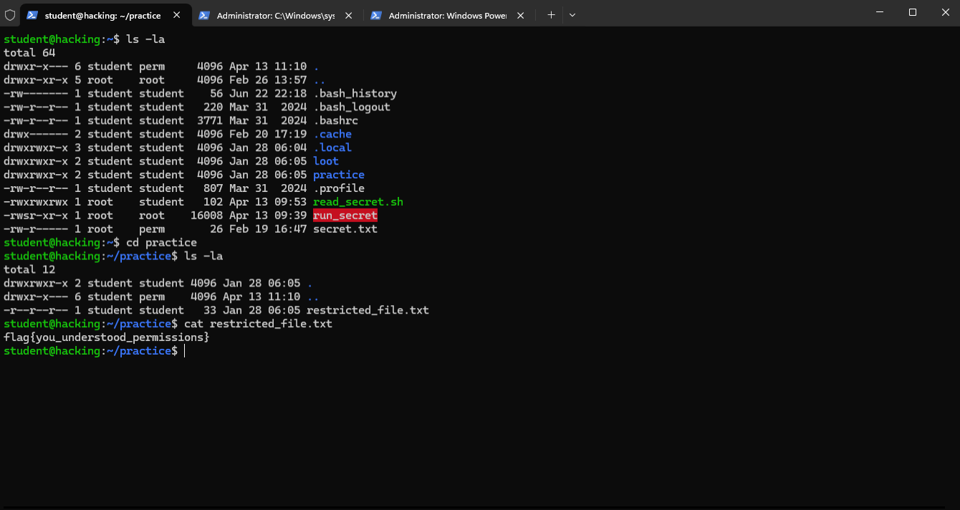
Figure 1: Linux permissions and restricted_file.txt content — flag{you_understood_permissions}

Environment Details
- Platform: TryHackMe (tutedude-cybersec room)
- OS: Ubuntu 24.04.4 LTS
- Target IP: 192.168.155.129
- Username: student
- Access Method: SSH via PowerShell

